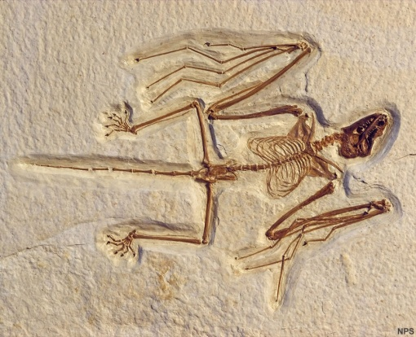
Fossils (p39-44)

What is a fossil?
- Define the term fossil.

- What can become a fossil?

- What two conditions must occur for a fossil to form and when are these conditions likely to occur?

Formation of fossils
- What is the fossil record?

- Why are not all organisms represented equally in the fossil record?

- List four organisms that are rare in the fossil record and give a reason why.

- Fossils of what sorts are organisms are more common? Give some examples.

- Describe how a fossil can be formed in the ocean.
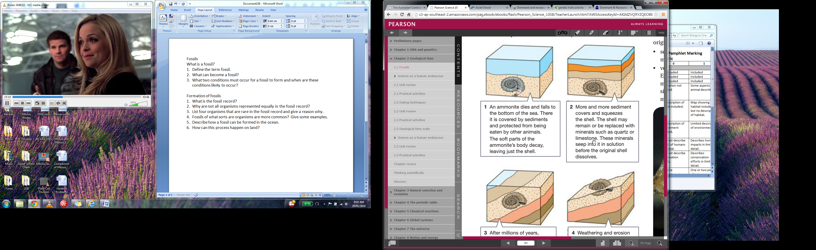

- How does this process happen on land?

Types of fossils
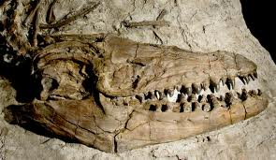
The many types of fossils are due to the different ways in which they can form and the type of organism being fossilised.

Original fossils
- Define an original fossil.

- What parts of an organism can form original fossils?

- List some common original fossils.
Replacement fossils
- Define a replacement fossil.

- Describe how a replacement fossil is formed.
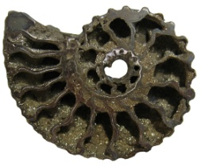

Carbon film fossils
- Define a carbon film fossil.

- What commonly forms a carbon film fossil?

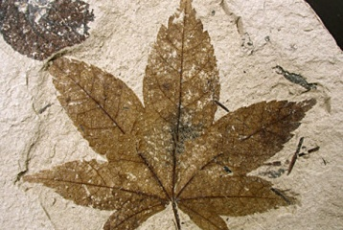
- Describe how a carbon film fossil is formed.

Indirect fossils
- Define an indirect fossil.

- What is a mould?

- Describe how a mould is formed.

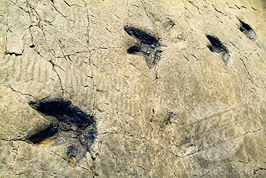

- Describe how a cast is formed.

Preserving environments
Hard parts of an organism have a better chance of survival than soft parts. However, some environments will encourage the preservation of soft parts.

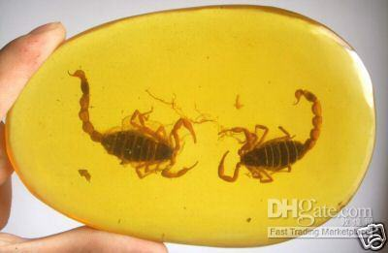
Describe how each of these can preserve organisms.

Permafrost

Amber

Tar

Peat

Dry air



